Unit 3: Lesson 13
Time and Energy! Where Do You Go?

Goal: To learn that the social and emotional positive actions of managing our time and managing our energy help us feel good about ourselves.

Does life lead you around in circles? Are you pulled in one direction, then another, then another? Do you fizzle out before your work does, with no energy left for fun or to share with others? If it weren’t for the last minute, would you get anything done?
How much we get done depends on how well we manage our resources of time and energy. We have a responsibility to manage our time and energy because these resources are limited. We can begin to manage them by deciding what’s most important to us. Then, even if we’re interrupted, we will find the time and energy to do the things we want and need to do.
At one time or another, most of us imagine what it would be like to be a boss – someone who has the ability to manage decisions and solve problems. Well, here’s the good news: We all have the capacity to be bosses or managers, especially of our own lives. So let’s put on our manager’s hat and see how it’s done.
Managing Our Time. Managing our resource of time is a positive action that helps us feel good about ourselves. We lead complicated, demanding lives. Striking a balance between what we have to do and what we want to do is necessary for good time management. We all have the same 24 hours in a day. So how we manage our time determines the quality of our lives.
A good way to manage time is to set priorities. We can set priorities by listing our activities in order of their importance to us. Then we can determine how much time we want to give to each activity. Activities that are most important should get more time than activities farther down our list.
Most of us value our families. Maybe earning a living, keeping house, or doing schoolwork are top priorities for us. They will probably require more time than we actually want to give them. Sharing meals, having fun together, and being with family and friends are family activities that need adequate time, too. We also need to keep some time for ourselves, including time to exercise and time to learn. And it’s important that we have some high-quality time to share with friends and others who might need our help.
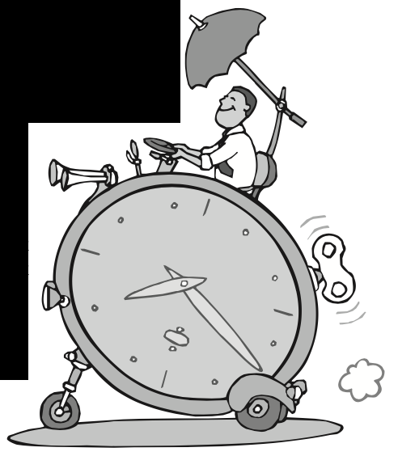
After determining the amount of time for each activity, we set up a monthly time schedule. We must realize that there will be conflicts with any schedule. Regardless of what we do, circumstances will sometimes require unscheduled time. We can deal with these interruptions more easily if we build in some flexibility.
Prioritizing our time and using it wisely might require us to limit or restructure some current activities. Saying no to activities that are not necessary or meaningful is good time management. Sometimes we might even have to say no or drop beneficial activities so we have time for others. We can also gain time by asking others to help with certain tasks. But we should never impose on them by asking for time they are unwilling to give. Our lives run smoother when we schedule our time. Managing our time wisely helps us feel good about ourselves. And it also affects how we manage our energy.
Managing Our Energy. Managing our energy is also a positive action that helps us feel good about ourselves. Energy gives us the ability to do things we do. We are using energy all the time. We all have periods of high energy and periods of low energy during the same day. Our energy levels can vary on different days. Since energy fuels our lives, it’s important that we take responsibility to manage the energy we have.
To a great extent, we manage our energy when we manage our time. Sometimes we can further manage our energy by rescheduling important activities to conform to our high energy levels. If our high energy level occurs in the morning, we make the best use of our energy by doing our high-priority activities at the same time.
Since our families are our top priority, we have a responsibility to save some our best energy for them. Often, the only big chunk of time we have with our families is evenings when almost everyone’s energy is low. Even so, we can manage our energy by scheduling family time when our work or school activities are lighter. We can move certain family activities to times when our energy levels are higher.
As with many other choices in our lives, our families are affected by how we choose to spend our time and energy. We have a responsibility to manage our time and energy so that we can share with our families and others. When we choose to manage our time and energy positively, we all benefit. If we choose to manage our time and energy negatively, then everyone affected by our choices suffer. And we always need to be careful not to demand more energy from others than they want to give.
Sometimes, when our energy is low, a change in activity can be as good as a rest. Adjusting our attitude can also help. A positive attitude energizes, while a negative attitude drains our energy. When we keep our priorities clear, our time and energy are used for activities that are important to us. Using our time and energy wisely helps us feel good about ourselves. So let’s start to manage these important personal resources.
QUESTIONS:
- Why is it important to manage our time and energy?
- How does setting priorities help us manage our time and energy?
- Why is it important to keep our priorities clear?
- How can we save some of our best time and energy for our family?
- How can we adjust to shifting energy levels?
- How does time and energy management affect self-concept?
- How does the way you use your time make you feel about yourself?
- What are your priorities?
- What changes would help you make better use of your time?
- How does the way you use your energy affect others?
- How do you balance what you have to do with what you want to do?

TIME CHART
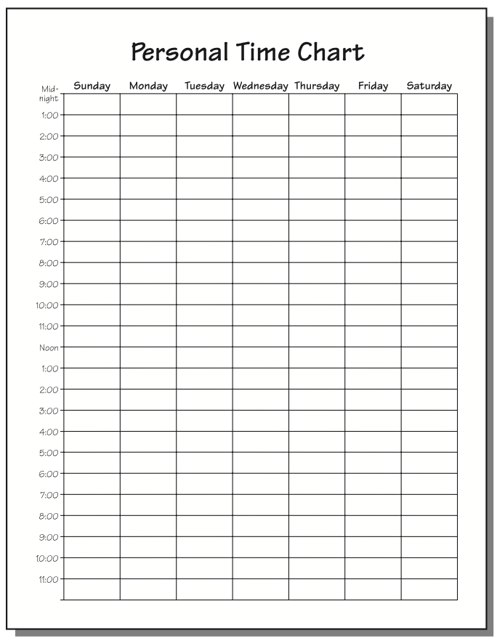

Use this chart to color in your non-flexible hours – such as when you sleep, eat, and attend school or work – using a different color for each category. That will leave only your free hours open. Then, with a pencil write down how you generally spend these open hours.
Your chart now gives you a good indication of how you use your free time and energy.
On the back of your chart list your free-time activities and assign priorities or order of importance. Then determine the amount of time per week you want to give each one. Be sure to include family time and some fun and leisure time among your top priorities.
Now decide what changes you need to make so your priorities get the amount of time you assigned. Keep some time open in your schedule for unplanned activities and emergencies.
Begin making your changes today. Notice how good you feel about yourself when you manage your time and energy positively.

FAMILY POSITIVE ACTIONS
QUESTIONS:
- Why is it important to manage our time as a family?
- How much time do we spend together as a family? Is it enough?
- What activities could we change or reschedule so we could spend more time together?
- How do we manage our energy as a family?
- What things could we do together to use our energy more positively?
parent positive actions

Ask Yourself: What five things in your life matter most to you? How do you feel about yourself when you spend time on these priorities? Do you spend special times with your children on a regular basis? How do you feel about yourself when you spend your high energy times with your family? Does your family spend as much time together as you would like? If not, what could you do to help change the situation?
Plan And Do: Find ways to use your time and energy more wisely. Write down an ideal daily schedule for yourself including time for your children.
Think of changes you could make that would bring your schedule closer to this ideal. Then decide to do one action that would change what happens to you during the day such as asking for help, saying no, rescheduling an activity.
Put your plan into action this week and pay attention to how you feel about yourself when you do.
Get a calendar or print one from the internet. Let’s develop a Family Calendar to help us practice the positive actions of managing our time and energy. We’ll keep track of chore times and other family events on this calendar. Everyone should also record his or her individual activities.
We will use this Family Calendar to determine available times for family activities. When we schedule family activities, we’ll mark them on the Family Calendar so everyone can plan to participate. By making a commitment to use this calendar, we can manage our time and consequently our energy more positively.

COMMUNITY POSITIVE ACTIONS
Let’s talk about the successful and happy people we know – people who get things done and have fun doing them. Let’s talk about the priorities they have. Maybe we can ask them during the week how they manage their time and energy. If we pay attention to their answers, we may learn something to help us manage our own time and energy better.
Let’s also talk about how we can find time and energy for serving the community and being with our family as well. As we find that managing our time and other resources frees us up to make more choices, we can make positive things happen that we never realized were possible.

SUMMARY
How we use our time and energy affects how we feel about ourselves. We feel good about ourselves when we use these resources well. We don’t feel as good about ourselves if we waste them or use them poorly. We can improve our self-concepts by managing our time and energy more positively.
We only have so much time and energy. That’s why it’s so important that we manage what we have. We take the first step by deciding what is important to us and then balancing it with what we have to do. These two groups of activities become our priorities.
We need to do the best we can to work what we want to do into our non-working or non-school time. Since our families are among our highest priorities, we need to make sure we schedule adequate time and energy for them. It’s also important to keep a little time for others. It’s best to plan our most important activities during our higher energy times whenever possible and yet be flexible.
Establishing priorities often requires changes in our present schedules. We may have to reschedule some activities, ask for help with others, or even say no to less meaningful ones to keep our priorities. When we have time and energy to do the things we want and need to do, we are managing our time and energy wisely, which helps us feel good about ourselves.

Word of the week:
Time:
When something happens (a period of seconds, minutes, hours, etc.
Energy:
The force to do something.

